‘What’s On’ at St. Paul’s Church this week
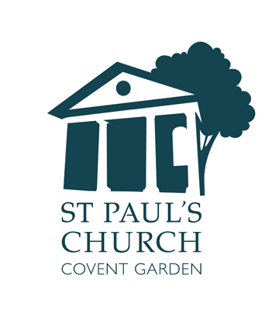
Sunday 28 April
11.00am Parish Sung Eucharist for the Fifth Sunday in Easter
12.15pm Annual Parochial Church Meeting

Monday 29 April
Church and grounds open 8.30am – 5.30pm

Tuesday 30 April
2.30pm TCUK Trustees’ meeting
Church and grounds open 8.30am – 5.30pm

Wednesday 1 May
Church and grounds open 8.30am – 5.30pm
12.00 Sandwich Lunch in church – all welcome
1.10pm Holy Eucharist
2pm Unveiling of the plaque to the late John Harwood RIP

Thursday 2 May
Church used as a Polling Station: closed for all church activities.
Grounds are open as usual

Friday 3 May
Church and grounds closed from 12pm
1pm Memorial Service for the late Joss Ackland RIP

Saturday 4 May
6.30pm & 8.30pm Musicals by Candlelight **

Sunday 5 May
11.00 Parish Sung Eucharist for the Sixth Sunday of Easter

Don’t forget the May Fayre and Puppet Festival will take place on Sunday 12 May from 12-5pm

